WEEK 1 TASK
Data Acquisition, Cleaning, and Exploratory Analysis
Titanic Passenger Survival Dataset

Dataset | Titanic passenger records
Source | Seaborn-data repository on GitHub
Raw size | 891 rows × 15 columns
Prepared size | 784 rows × 10 columns

Prepared as a reproducible Week 1 data preparation exercise

1. Executive Summary
This report documents a complete first-pass data preparation workflow using the Titanic passenger dataset. The workflow covers acquisition from a public URL, structural inspection, missing-value treatment, exact-duplicate removal, data-type correction, feature engineering, exploratory analysis, and communication of findings.
The raw dataset contained 891 records and 15 fields. It included 869 missing cells and 107 exact duplicate rows. After cleaning, the analysis-ready dataset contained 784 records, 10 retained fields, and no missing values.
The overall survival rate in the cleaned data was 41.2%. The strongest descriptive differences were associated with sex and passenger class. Female passengers had a survival rate of 74.1%, compared with 21.6% for male passengers. First-class passengers had a survival rate of 63.1%, compared with 25.7% in third class.

2. Data Acquisition
The Titanic dataset was selected because it is small enough for a transparent Week 1 workflow while still containing numerical, categorical, and missing-value challenges. It supports meaningful exploratory questions without requiring a complex modelling setup.
Public source used
https://raw.githubusercontent.com/mwaskom/seaborn-data/master/titanic.csv
Acquisition code
import pandas as pd
source_url = "https://raw.githubusercontent.com/mwaskom/seaborn-data/master/titanic.csv"
titanic_raw_df = pd.read_csv(source_url)
print(titanic_raw_df.shape)
print(titanic_raw_df.head())

3. Initial Data Profiling
Initial profiling was used to understand the schema before changing any values. The raw data contained binary indicators, categorical labels, continuous measurements, and several columns that expressed the same concept in different forms.
Area | Finding | Implication | Action
Missingness | age 177, deck 688, embarked 2, embark_town 2 | Some variables require imputation or removal | Impute age and embarked; remove deck
Duplicates | 107 exact duplicate rows | Repeated complete records can bias summaries | Drop exact duplicates
Types | Mixed numeric, object, boolean, and categorical fields | Consistent types are needed for grouping and modeling | Cast numeric and categorical fields explicitly
Redundancy | class, who, adult_male, alive, alone duplicate information | Redundant fields complicate interpretation | Retain a compact analytical feature set

4. Data Cleaning and Preprocessing
The cleaning choices were conservative and designed to preserve as much information as possible while making the data analysis-ready.
Step | Method | Rationale
Exact duplicates | Removed complete duplicate rows using drop_duplicates() | Prevents repeated records from inflating counts and rates.
Category standardization | Trimmed text and normalized sex and embarked labels | Ensures equivalent labels group together consistently.
Age imputation | Filled missing age with the median within passenger class and sex groups | Uses relevant subgroups and is less sensitive to outliers than a mean.
Embarkation imputation | Filled two missing embarked values with the modal port | Very low missingness makes mode imputation simple and transparent.
Deck handling | Dropped deck because 688 of 891 raw values were missing | A variable with roughly 77% missingness would contribute limited reliable information.
Feature engineering | Created family_size = sibsp + parch + 1 and is_alone_derived | Provides an interpretable family-structure measure for EDA.
Redundant fields | Retained core fields and removed duplicate semantic representations | Keeps the analysis focused and reduces avoidable multicollinearity.

Cleaning code
clean_df = titanic_raw_df.drop_duplicates().reset_index(drop=True)
clean_df['sex'] = clean_df['sex'].str.lower().str.strip().astype('category')
clean_df['embarked'] = clean_df['embarked'].str.upper().str.strip()
clean_df['age'] = (
clean_df.groupby(['pclass', 'sex'], observed=True)['age']
.transform(lambda s: s.fillna(s.median()))
)
clean_df['embarked'] = clean_df['embarked'].fillna(clean_df['embarked'].mode().iloc[0])
clean_df['family_size'] = clean_df['sibsp'] + clean_df['parch'] + 1
clean_df['is_alone_derived'] = clean_df['family_size'].eq(1)

5. Exploratory Data Analysis

5.1 Missing-value assessment
Missingness was concentrated in deck and age. The post-cleaning comparison confirms that the selected imputation rules removed missing values from the retained analytical fields, while deck was excluded rather than heavily imputed.
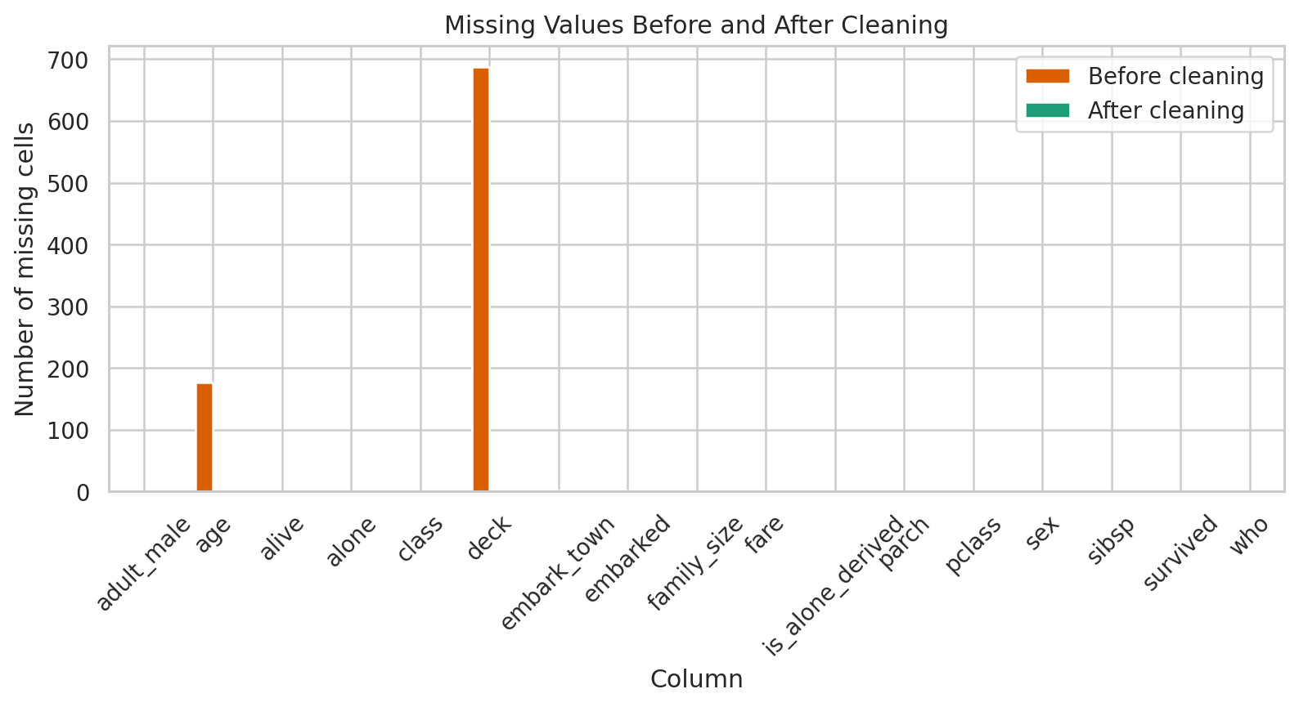
Figure 1. Missing values before and after cleaning.

5.2 Survival by sex and passenger class
Survival varied substantially across sex and class. The grouped bar chart shows that female survival was higher than male survival within each class, while first-class survival was higher than third-class survival within each sex. These are descriptive associations, not causal estimates.
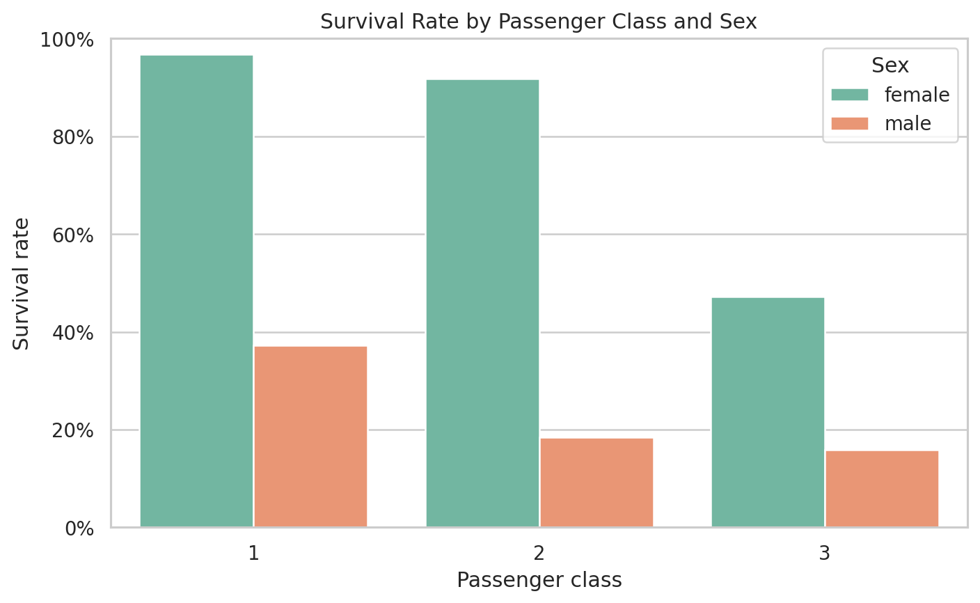
Figure 2. Survival rate by passenger class and sex.

5.3 Age distribution
The age distributions overlap for survivors and non-survivors, but the plot also highlights the presence of children and the broad adult age range. The imputed ages should be treated as suitable for descriptive analysis, not as observed measurements.
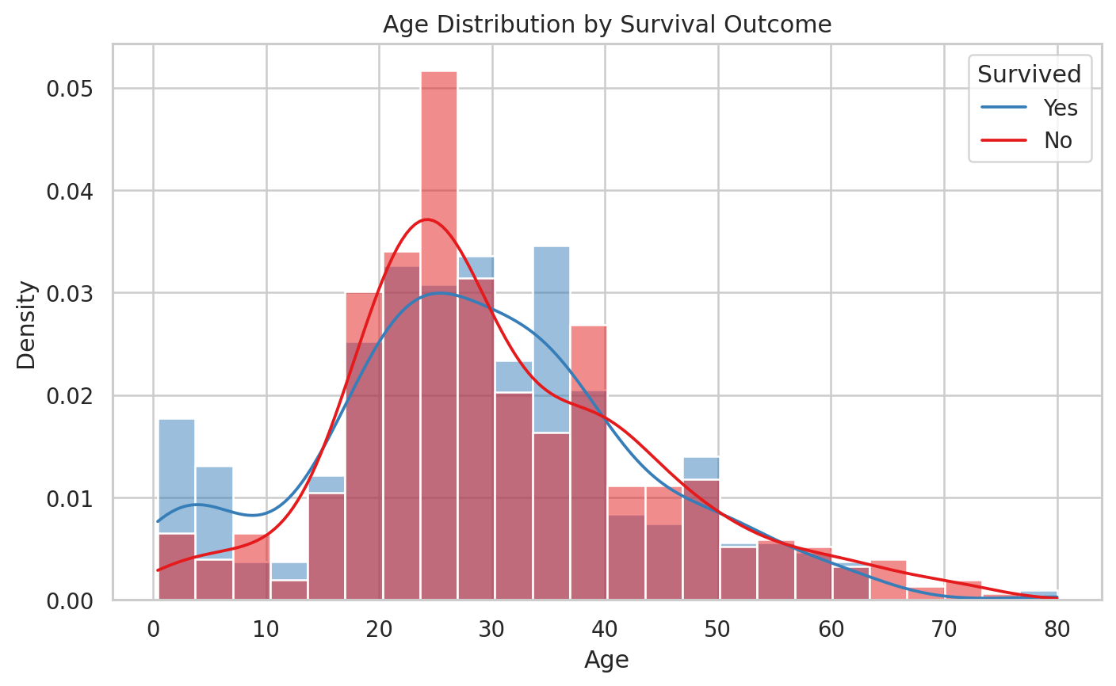
Figure 3. Age distribution by survival outcome.

5.4 Numeric relationships
The correlation matrix provides a compact view of linear relationships among numeric variables. Survival is positively associated with fare and negatively associated with passenger-class number, where a lower class number represents a higher class. Family size is mechanically related to sibsp and parch because it was constructed from those fields.
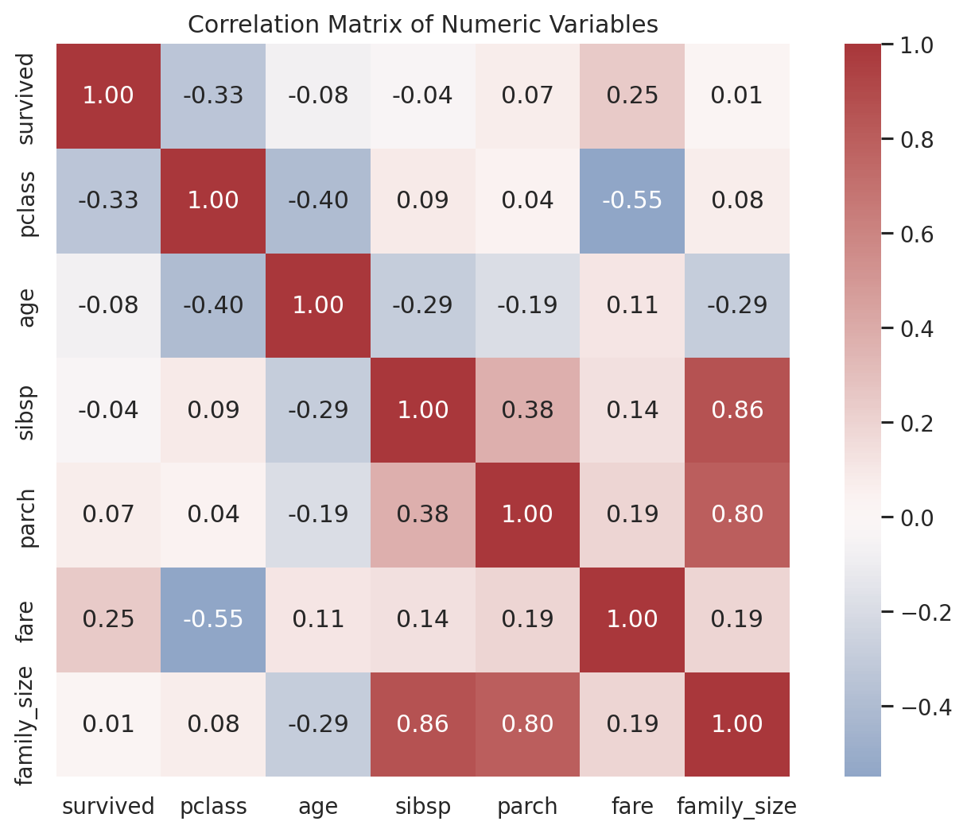
Figure 4. Correlation matrix for numeric variables.

6. Key Insights
- Overall survival was 41.2%, providing a baseline for later predictive modelling.
- Female passengers survived at 74.1%, versus 21.6% for male passengers. This is the largest simple group difference examined.
- First-class survival was 63.1%, versus 25.7% for third class, suggesting a strong relationship between class and outcome.
- Passengers traveling with at least one family member had a survival rate of 51.2%, compared with 33.6% for passengers traveling alone.
- The median fare was $26.25 among survivors and $13.00 among non-survivors, consistent with the relationship between fare and passenger class.

7. Limitations and Next Steps
Important limitations
- The dataset is historical and observational, so the descriptive relationships should not be interpreted as causal effects.
- The exact duplicate rule assumes repeated complete rows are data duplicates. In a real operational dataset, a unique passenger identifier would be preferable.
- Age imputation introduces estimated values and may reduce natural variability. A sensitivity analysis could compare median imputation with model-based or multiple imputation.
- Several variables are closely related, such as pclass and fare, so a later predictive model should check multicollinearity and feature importance carefully.
Recommended next steps
- Build a reproducible train-validation split and establish a baseline classifier.
- Compare logistic regression, decision tree, and tree-ensemble models.
- Evaluate performance with accuracy, precision, recall, F1, and ROC-AUC rather than accuracy alone.
- Use cross-validation and inspect fairness-related performance differences across sex and passenger class.
- Create a data dictionary and automated validation checks for future versions of the dataset.

8. Suggested 30–35 Hour Work Plan
Activity | Estimated hours | Outputs
Dataset selection and acquisition | 3–4 | Source evaluation and reproducible download
Profiling and cleaning | 8–10 | Quality checks, missingness treatment, type corrections
EDA and visualizations | 10–12 | Summary statistics and four figures
Interpretation and validation | 4–5 | Cross-checks and limitations
Documentation and formatting | 5–6 | Final report, code snippets, and exported files

Appendix A. Reproducibility Checklist
- Public source URL recorded in the report.
- Raw row and column counts captured before cleaning.
- Missing-value counts compared before and after cleaning.
- Exact duplicate count measured and documented.
- Cleaning logic written in Python using pandas.
- Four visualisations saved with descriptive filenames.
- Cleaned CSV exported alongside the report.

